**SAVEETHA SCHOOL OF ENGINEERING**

**CSA1142-OBJECT ORIENTED ANALYSIS AND DESIGN**

**QUESTION 5: ONLINE COURSE REGIISTRATION**

**USE CASE**

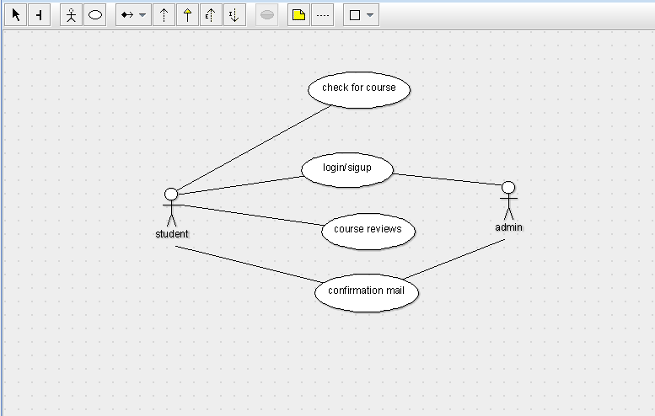

STATE DIAGRAM

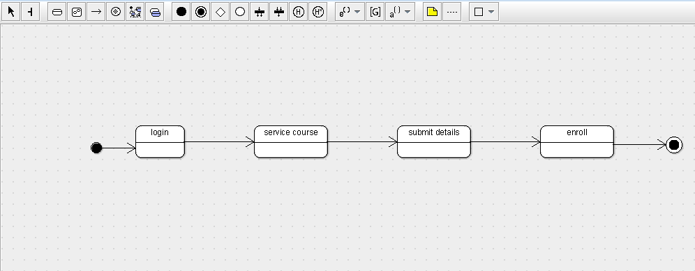

SEQUENCE DIAGRAM

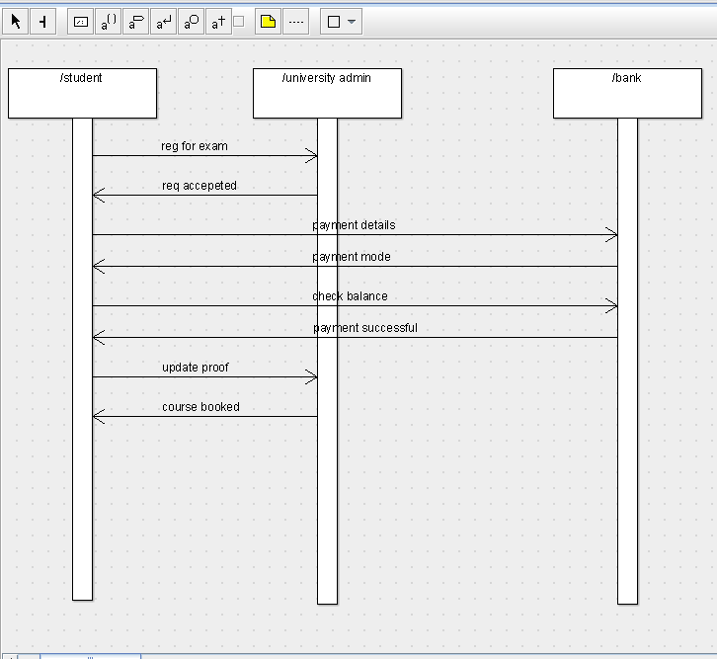

PACKAGE DIAGRAM

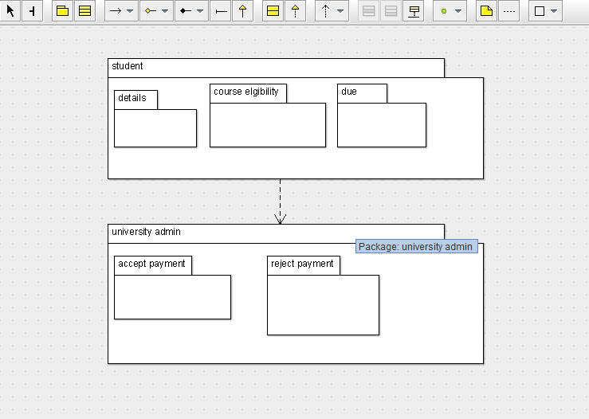

DEPLOYMENT DIAGRAM

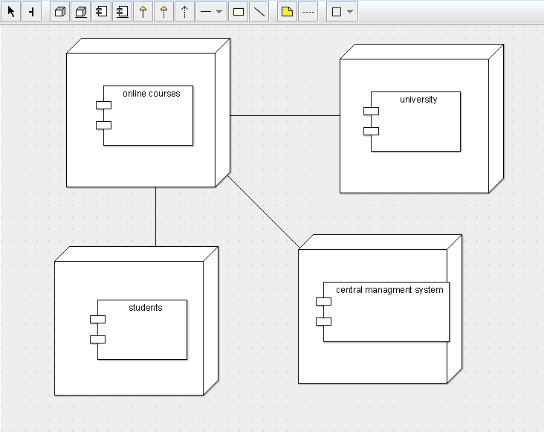

COMPONENT DIAGRAM

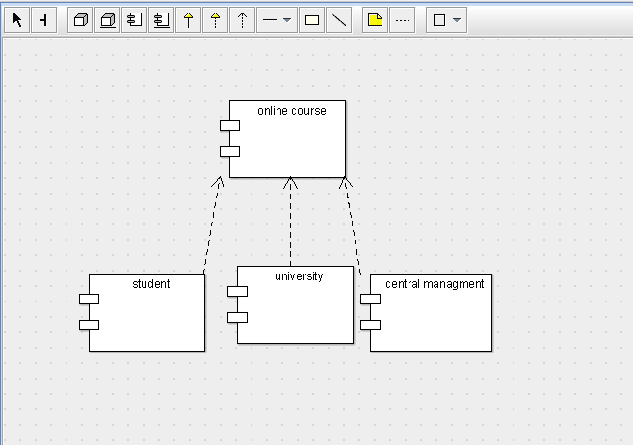

COLLABORATION DIAGRAM

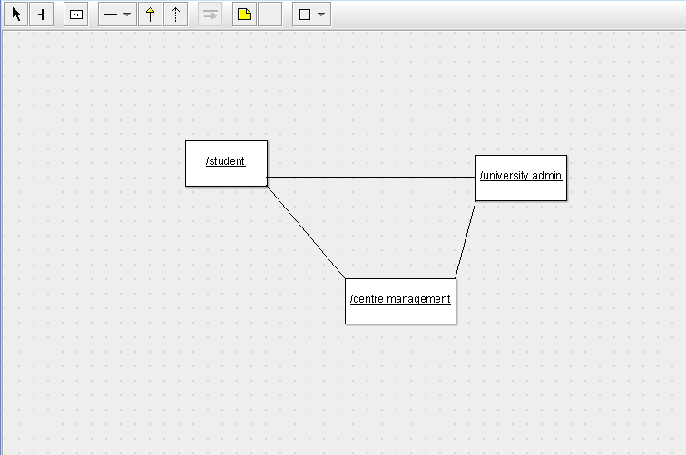

CLASS DIAGRAM

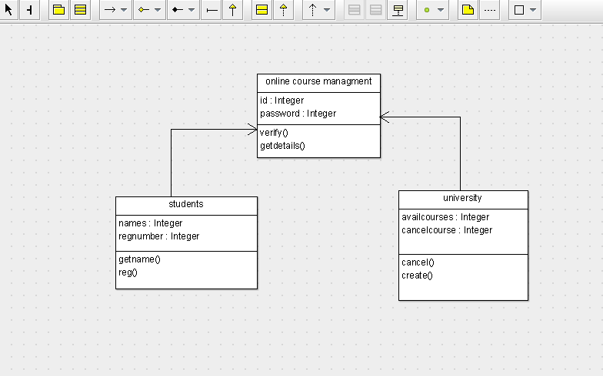

ACTIVITY DIAGRAM

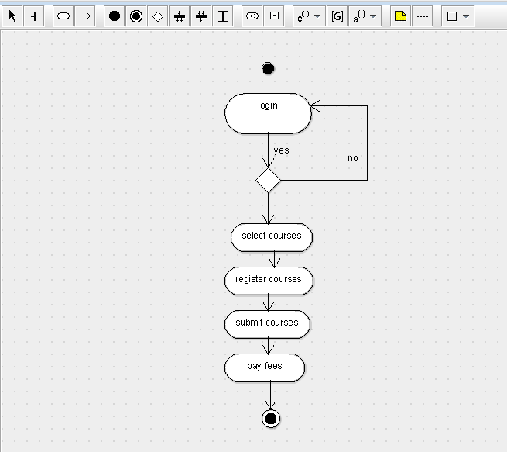

SKELETON CODE:

import java.util.Vector;

public class university {

public Integer availcourses;

public Integer cancelcourse;

public Vector myonline course managment;

public void cancel() {

}

public void create() {

}

}

import java.util.Vector;

public class students {

public Integer names;

public Integer regnumber;

public Vector myonline course managment;

public void getname() {

}

private void reg() {

}

}

public class online course managment {

private Integer id;

public Integer password;

public void verify() {

}

public void getdetails() {

}

}